NINTENDO WII CODE:

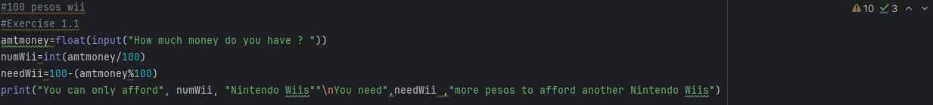

OUTPUT:

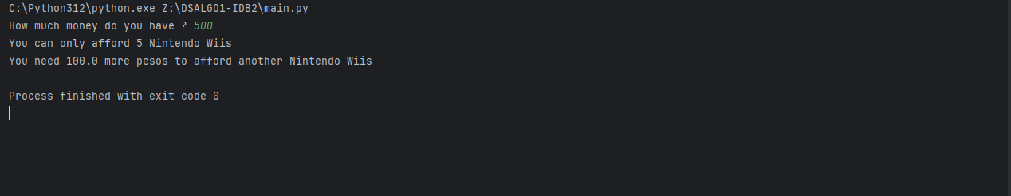

FACTORIAL CODE:



OUTPUT:

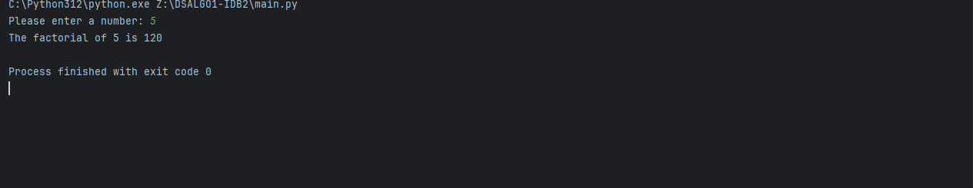

FACTORS CODE:

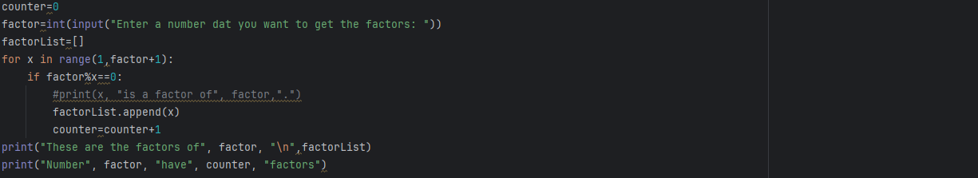

OUTPUT:

